**Question 1: Implement the class ‘course’. Allow user to input and then display information.**

//summary: this program makes a class called course. This holds the name, section, number of students,

// and location for a course. This program takes in user input and then displays it

//name: Jenna Wolf

//class: Computer Science II, CS-265

//instructor: Mr. Waleed Amer

//date: 02/05/2023

import java.util.Scanner;

public class Main {

public static void main(String[] args) {

Scanner input = new Scanner(System.in); //lets inputs be made

course user = new course(); //holds the user data

//takes in all information from user

System.out.print("Enter the name of your course: ");

user.setName(input.next());

System.out.print("Enter the section for your course: ");

user.setSection(input.next());

System.out.print("Enter the number of students for your course: ");

user.setNumberStudents(input.nextInt());

System.out.print("Enter the location of your course: ");

user.setLocation(input.next());

//outputs all information from user

System.out.println("Course name: " + user.getName());

System.out.println("Course section: " + user.getSection());

System.out.println("Course number of students: " + user.getNumberStudents());

System.out.println("Course location: " + user.getLocation());

}

public static class course {

String name; //holds the name data

String section; //holds the section data

int numberStudents; //holds the numberStudents data

String location; //holds the location data

//no args constructor

course() {

name = " ";

section = " ";

numberStudents = 0;

location = " ";

}

//constructor with 4 arguments

course(String temp1, String temp2, int temp3, String temp4) {

name = temp1;

section = temp2;

numberStudents = temp3;

location = temp4;

}

//sets the name variable to the value sent over

void setName(String temp) {

name = temp;

}

//sets the name section to the value sent over

void setSection(String temp) {

section = temp;

}

//sets the name numberStudents to the value sent over

void setNumberStudents(int temp) {

numberStudents = temp;

}

//sets the name location to the value sent over

void setLocation(String temp) {

location = temp;

}

//returns the name data

String getName() {

return name;

}

//returns the section data

String getSection() {

return section;

}

//returns the numberStudents data

int getNumberStudents() {

return numberStudents;

}

//returns the location data

String getLocation() {

return location;

}

}

}

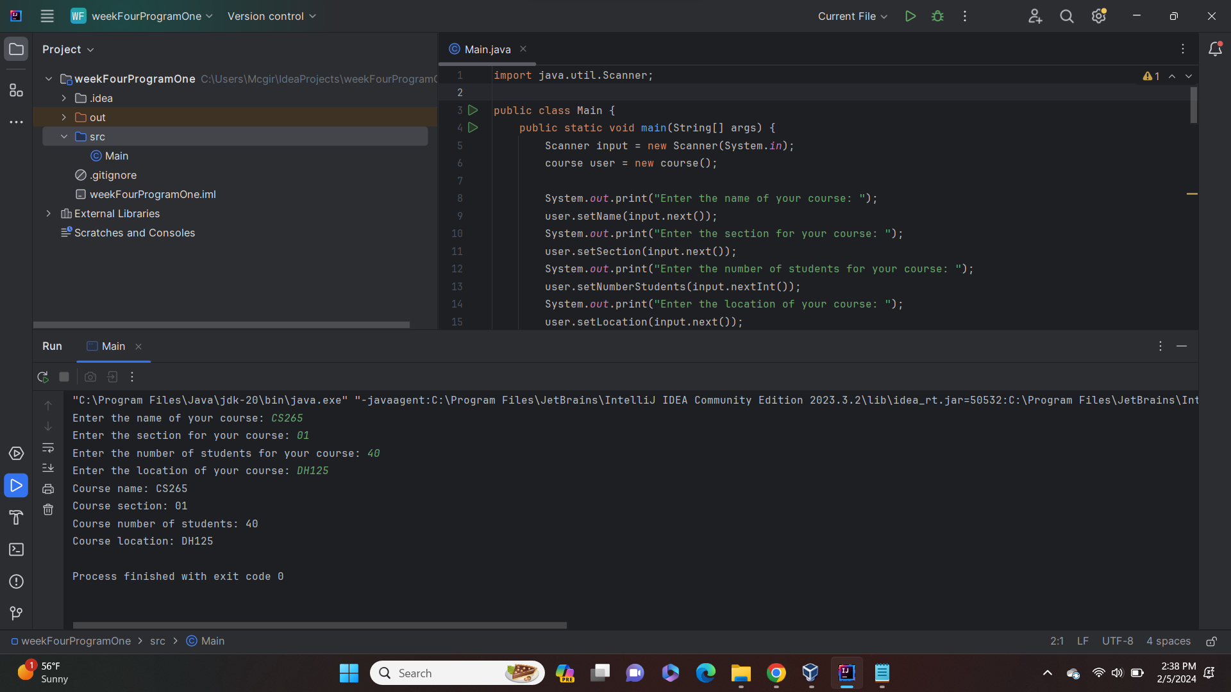

**Question 2: Write a program to define the ‘Course’ class that has a name, numberOfSeats, department and numberOfCourses (which will keep track of how many objects have been created of this class and allow users to get that value).**

//summary: this program makes a class called course. This class has a static variable that adds 1

//everytime a new course variable is made. This program tests that function out.

//name: Jenna Wolf

//class: Computer Science II, CS-265

//instructor: Mr. Waleed Amer

//date: 02/05/2023

public class Main {

public static void main(String[] args) {

course C1 = new course("CS155", 40, "CS"); //holds the C1 data

System.out.println("number of courses: " + C1.getNumberOfCourses()); //displays numberOfCourses

course C2 = new course("CS265", 40, "CS"); //holds the C2 data

System.out.println("number of courses: " + C1.getNumberOfCourses()); //displays numberOfCourses

course C3 = new course("CS300", 25, "CS"); //holds the C3 data

course C4 = new course("CS315", 30, "CS"); //holds the C4 data

System.out.println("number of courses: " + C1.getNumberOfCourses()); //displays numberOfCourses

}

public static class course {

String name; //holds the name data

int numberOfSeats; //holds the numberOfSeats data

String department; //holds the department data

static int numberOfCourses = 0; //holds the numberOfCourses data (static)

//no args constructor

course() {

name = " ";

numberOfSeats = 0;

department = " ";

numberOfCourses++;

}

//constructor that sets data to values sent over

course(String temp1, int temp2, String temp3) {

name = temp1;

numberOfSeats = temp2;

department = temp3;

numberOfCourses++;

}

//sets name to the value sent over

void setName (String temp) {

name = temp;

}

//sets numberOfSeats to the value sent over

void setNumberOfSeats (int temp) {

numberOfSeats = temp;

}

//sets department to the value sent over

void setDepartment (String temp) {

department = temp;

}

//returns the numberOfCourses data

static int getNumberOfCourses() {

return numberOfCourses;

}

}

}

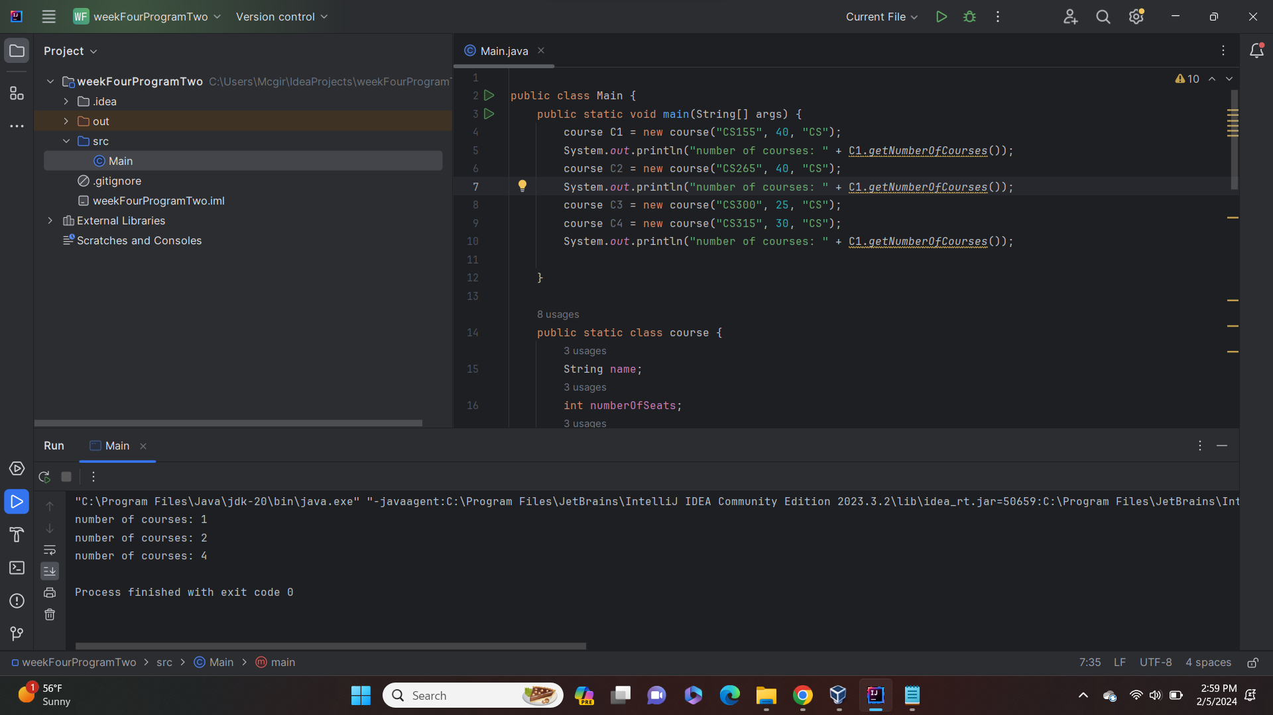

**Question 3: Write a program to design a new Square class and then Print a table of areas for lengths 10 to 15. The program will pass the object to the print method.**

//summary: this program makes a class called square. This programs uses that classes print method

//to print out the classes values multiple times.

//name: Jenna Wolf

//class: Computer Science II, CS-265

//instructor: Mr. Waleed Amer

//date: 02/05/2023

public class Main {

public static void main(String[] args) {

square test = new square(); //holds the test data

System.out.println("length | area"); //outputs a header line

//for loop that goes until areas for squares 10 to 16 are printed

for(int i = 10; i < 16; i++) {

test.setLength(i);

test.print();

}

}

public static class square {

double length; //holds the length data

//no args constructor

square() {

length = 1;

}

//constructor that sets data

square(double temp) {

length = temp;

}

//returns the length variable

double getLength() {

return length;

}

//returns the area data

double getArea() {

return length * length;

}

//sets length to the data sent over

void setLength( double temp) {

length = temp;

}

//prints out the length and area of a square

void print() {

System.out.println(length + " " + getArea());

}

}

}

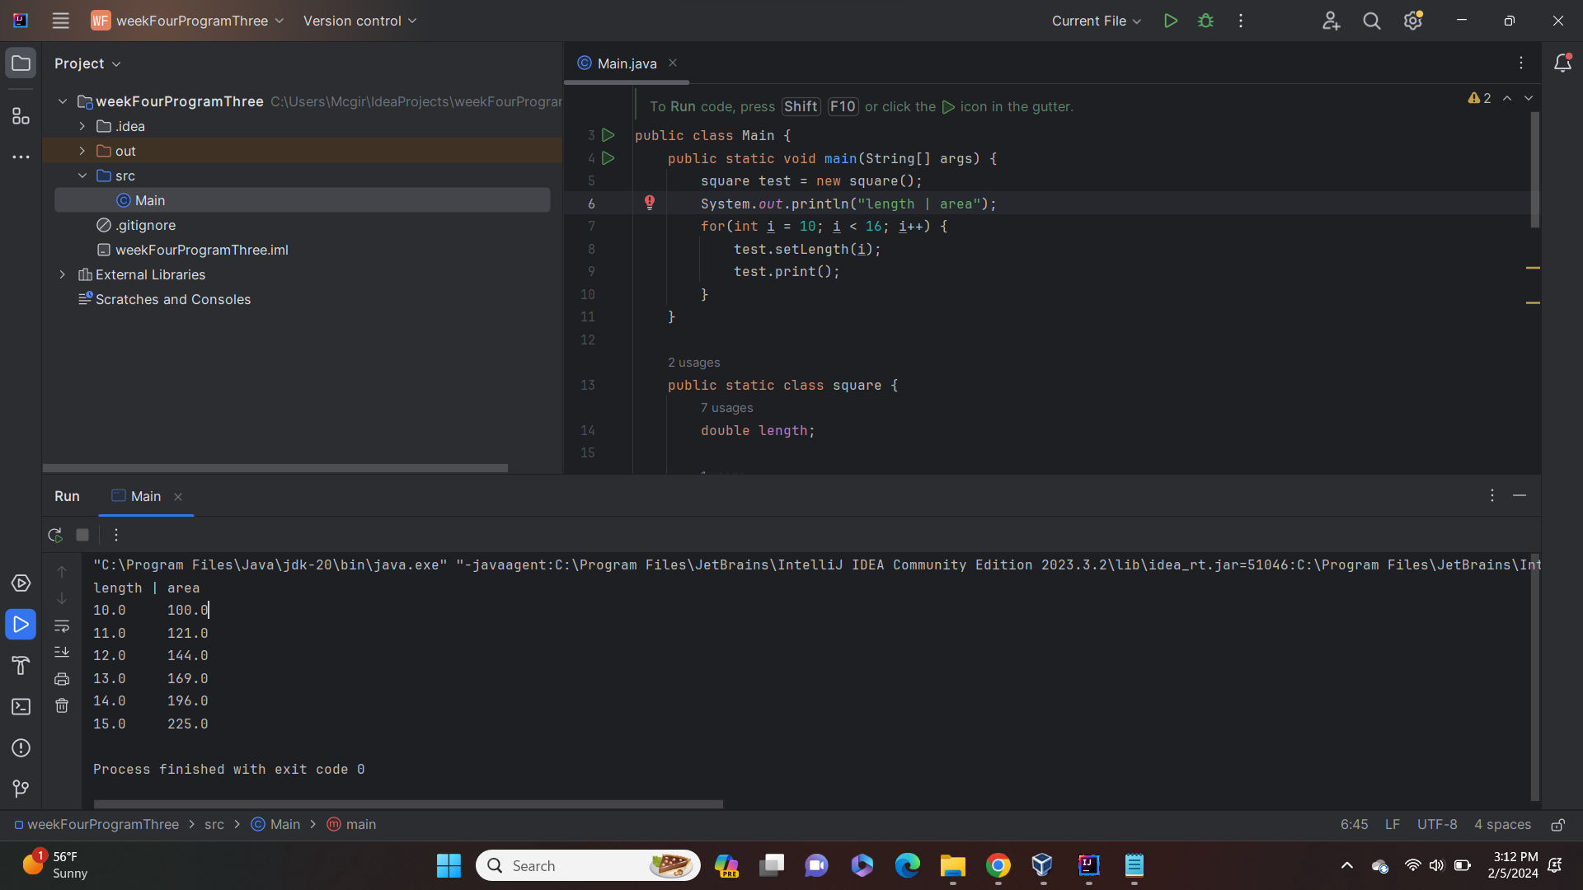

**Question 4: Implement the class ‘Student’ which allows the user to setID(), setExams(), setQuizzes(), setAssignments(), getID(), getTotal().**

//summary: this program makes a class called student. This program makes an array of

//type student, lets the user fill in the information for each student, and then outputs

//the id and total for each student

//name: Jenna Wolf

//class: Computer Science II, CS-265

//instructor: Mr. Waleed Amer

//date: 02/05/2023

import java.util.Scanner;

public class Main {

public static void main(String[] args) {

Scanner input = new Scanner(System.in); //lets inputs be made

//takes in num from the user

System.out.print("Enter the number of students you want to process: ");

int num = input.nextInt();

student[] students = new student[num]; //creates an array of size num

//makes an empty student for each array cell

for(int i = 0; i < num; i++) {

students[i] = new student();

}

//lets user fill in all information for a student

for(int i = 0; i < num; i++) {

System.out.print("Enter information for student " + (i + 1) +": ");

students[i].setID(input.nextInt());

students[i].setExams(input.nextDouble());

students[i].setQuizzes(input.nextDouble());

students[i].setAssignments(input.nextDouble());

}

//prints a table of students ID and total score

System.out.println("Student ID | Total Score");

for(int i = 0; i < num; i++) {

System.out.printf("%-12d", students[i].getID());

System.out.println(students[i].getTotal());

}

}

public static class student {

int ID; //holds the ID data

double exams; //holds the exams data

double quizzes; //holds the quizzes data

double assignments; //holds the assignments data

//no args constructor

student () {

ID = 0;

exams = 0;

quizzes = 0;

assignments = 0;

}

//constructor that sets variables to data sent over

student (int temp1, double temp2, double temp3, double temp4) {

ID = temp1;

exams = temp2;

quizzes = temp3;

assignments = temp4;

}

//sets ID to the data sent over

void setID(int temp) {

ID = temp;

}

//sets exams to the data sent over

void setExams(double temp) {

exams = temp;

}

//sets quizzes to the data sent over

void setQuizzes(double temp) {

quizzes = temp;

}

//sets assignments to the data sent over

void setAssignments(double temp) {

assignments = temp;

}

//returns data stored in ID

int getID() {

return ID;

}

//returns the toal of exams, quizzes, and assignments

double getTotal() {

return exams + quizzes + assignments;

}

}

}

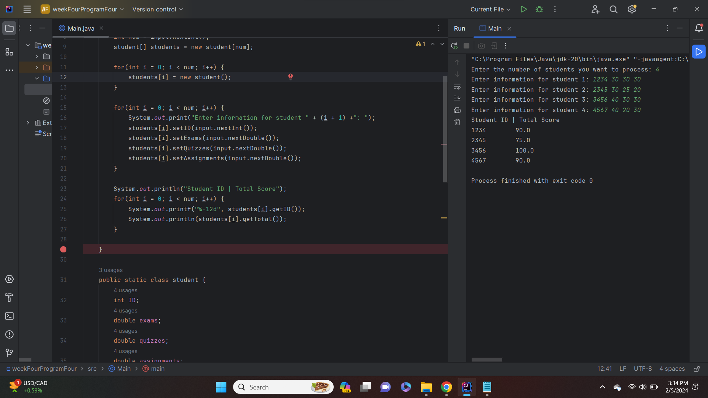

**Question 5: Write a program to create one objects of the Random class and set its seed 5.**

//summary: this program uses the random class to generate 5 random variable between 0 and 100.

//it then tells the user weather those numbers are greater than, less than, or equal to 50

//name: Jenna Wolf

//class: Computer Science II, CS-265

//instructor: Mr. Waleed Amer

//date: 02/05/2023

import java.util.Random;

public class Main {

public static void main(String[] args) {

Random ran = new Random(5); //lets random values be made

int num = 0; //holds the num data

//for loop that iterates until i is greater than 5

for(int i = 0; i < 5; i++) {

//generates and displays a random number

num = ran.nextInt(101);

System.out.println("Random number: " + num);

//dispalys weather the number is greater than, less than, or equal to 50

if(num > 50)

System.out.println("This number is greater than 50");

if(num < 50)

System.out.println("This number is less than 50");

else

System.out.println("This number is equal to 50");

}

}

}

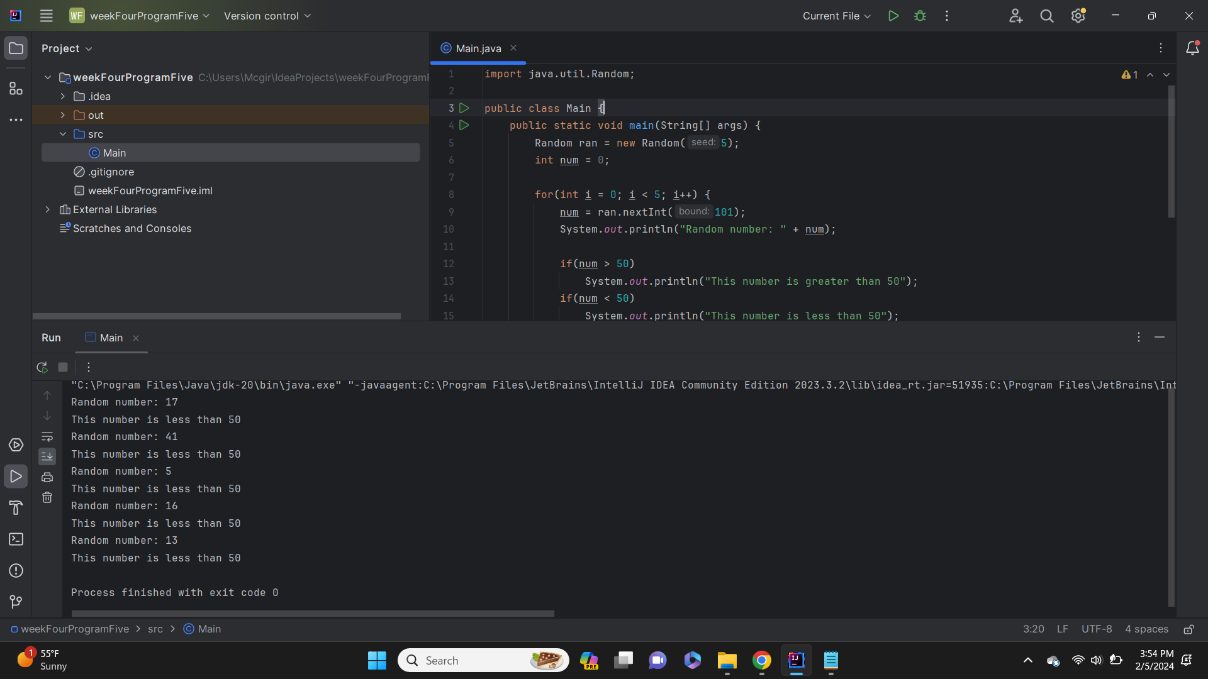

**Question 6: Implement the class ‘TestPoint3D ‘. Write a test program to read the coordinates of 3 points (P1, P2 and P3)**

//summary: this program uses make the testPoint3D class. It takes in three points from the user and

//find the distance between the first and second point and the first and third point.

//name: Jenna Wolf

//class: Computer Science II, CS-265

//instructor: Mr. Waleed Amer

//date: 02/08/2023

import java.lang.Math; //allows math equations

import java.util.Scanner; //allows inputs to be made

public class Main {

public static void main(String[] args) {

Scanner input = new Scanner(System.in); //names the input

int x, y; //holds the x and y data

//takes in the first point

System.out.print("Enter your values for x1 and y1: ");

x = input.nextInt();

y = input.nextInt();

TestPoint3D point1 = new TestPoint3D(x, y);

//takes in the second point

System.out.print("Enter your values for x2 and y2: ");

x = input.nextInt();

y = input.nextInt();

TestPoint3D point2 = new TestPoint3D(x, y);

//takes in the third point

System.out.print("Enter your values for x2 and y2: ");

x = input.nextInt();

y = input.nextInt();

TestPoint3D point3 = new TestPoint3D(x, y);

//finds the distance between the points and displays them

double Distance1 = Math.sqrt(Math.pow(point1.x - point2.x, 2) + Math.pow(point1.y - point2.y, 2));

double Distance2 = Math.sqrt(Math.pow(point1.x - point3.x, 2) + Math.pow(point1.y - point3.y, 2));

System.out.println("the distance between the first point and second point is: " + Distance1 );

System.out.println("the distance between the first point and third point is: " + Distance2 );

}

public static class TestPoint3D {

int x, y; //holds the x and y data

//no args constructor

TestPoint3D() {

x = 0;

y = 0;

}

//constructor that sets x and y

TestPoint3D(int temp1, int temp2) {

x = temp1;

y = temp2;

}

//sets x to the value sent over

void setX(int temp) {

x = temp;

}

//sets y to the value sent over

void setY(int temp) {

y = temp;

}

}

}

